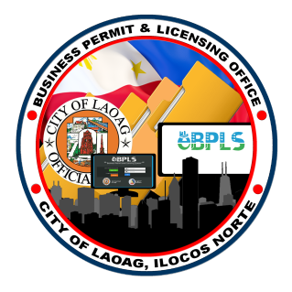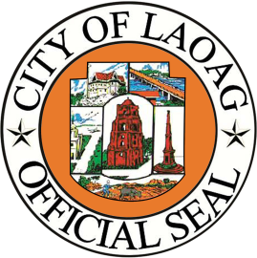**REPUBLIC OF THE PHILIPPINES**

Province of Ilocos Norte

OFFICE OF THE CITY MAYOR

BUSINESS PERMIT AND LICENSING OFFICE

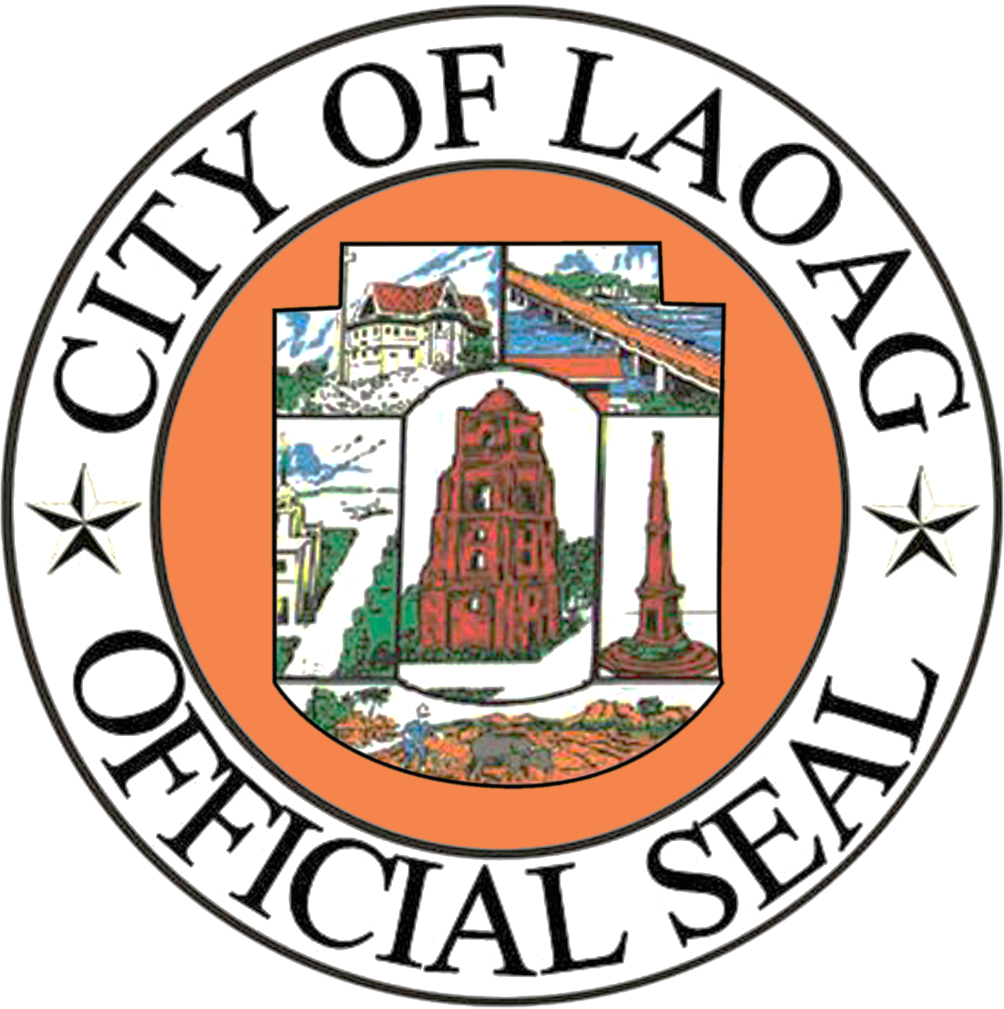

**MAYOR’S PERMIT**

**PERMIT NO: 12812-073-2025 DATE: 04/08/2025**

THIS CERTIFIES that

**MAMINTO MACABAAS**

Of Brgy. 1 Muslim Compound, Laoag City Ilocos Norte

Is engaged in selling of:

**FOOTWEAR/DRY GOODS**

AT Brgy. 15 Puregold Bldg., Laoag City, Ilocos Norte

has been granted to operate the following business/es

**RETAILER**

**This permit is subject to the condition that all Laws, Ordinances, Resolutions, General Orders, Presidential Decrees, Letters of Instructions and Letters of Implementation governing the matter that shall be strictly complied with.**

**VALID UP TO DECEMBER 31, 2025**

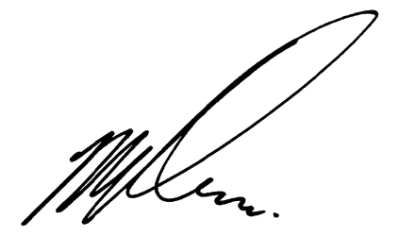**APPROVED:**

OR No.2875985

Fees Paid: P 3,378.00

Date: April 07, 2025

**MICHAEL MARCOS KEON**

**City Mayor**